Automated Meeting Room Booking System

Project Scope:

The system automates the procedure of booking a meeting room in a company. Along with this, there is functionality to create rooms, create meetings and view meetings in which an employee is part of.

Users:

The system consists of three types of Users (Employees)

1. Admin
   1. Creates and configures meeting rooms
   2. Inserts the users into the system with json data
2. Managers
   1. Books a room for a meeting
   2. Can rate meeting which took place, delete a meeting which is scheduled.
   3. Can view meetings which he organized
   4. Can view meetings in which he is part of.
3. Members
   1. Can view meetings of which he is part of.

Packages:

Root package of this project is com.hsbc.system

SubPackages:

* Model:

This package contains all Bean(Entity) classes used in this project.

* Controller:

This package contains all servlets which handles incoming request.

* Dao:

This package contains Java Classes which performs database operations used in this project.

* Util:

This package contains Java Classes which are common for entire application like DatabaseConnection (to connect to database).

* Exception:

This package contains Custom Exception’s Java Classes.

JSP:

Jsp pages are used to display data, take inputs from client and collect data in forms and forward to server.

Derby Db:

The project contains the following tables which are used to store the data.

* Users – This table stores all details of user and stores his role (Admin, Member, Manager);
* MeetingRoom – This table stores details of room like seating capacity, ratings, etc.
* RoomAmenities- This table stores the amenities available in a particular room.
* RoomType – This table defines the type of the room based on the amenities it provides.
* BookingInfo – This table contains info of scheduled meetings along with start and end time and date. It also stores who organized a particular meeting.
* Meeting – This table contains the meetings details which are present in BookingInfo table like Title, Description, etc.
* Attend- This table contains the information about users and the meetings in which he is invited.

Cron Job:

The task is to renew back the managers credits to 2000 points on every Monday morning. So it is a weekly cron. We are performing this task with the help of Windows Task Scheduler by using powershell Script. In this the task scheduler will hit the servlet url on every monday morning and credits will get updated.

Program/Script**:** powershell.exe

Arguments**:** - Command "Invoke-WebRequest http://localhost:8080/AutomatedBookingSystem/cronservlet"

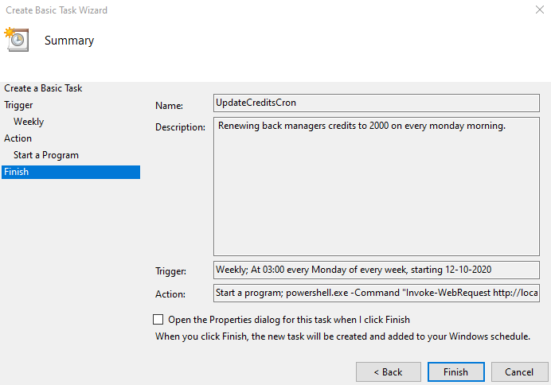

Fig: Snapshot of task scheduler.